**Week -2 Assignment**

Done by;

T.Harsha vardhan

20MIS7038

Code:

create table details.sdetails( name varchar(1), rn varchar(2)) ; insert into details.sdetails values ("N" , 1); insert into details.sdetails values ("G" , 2); insert into details.sdetails values ("E" , 3); select * from details.sdetails; update details.sdetails set rn = 5

WHERE name="N";

delete from details.sdetails where name = "N";

select * from details.fdetails; create table details.fdetails( fname varchar(1), fn varchar(2)) ; insert into details.fdetails values ("q" , 1); insert into details.fdetails values ("r" , 2); insert into details.fdetails values ("t" , 3);

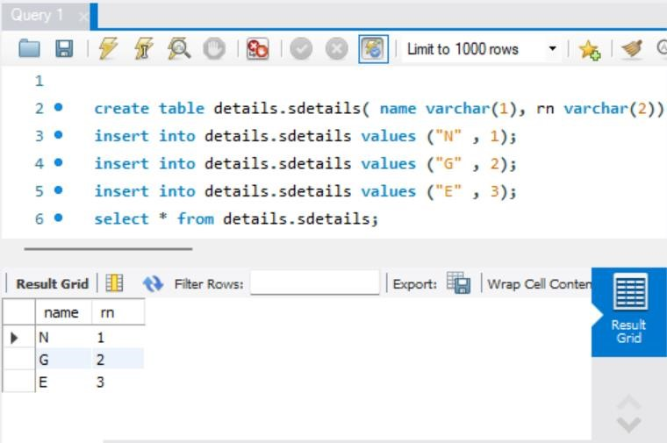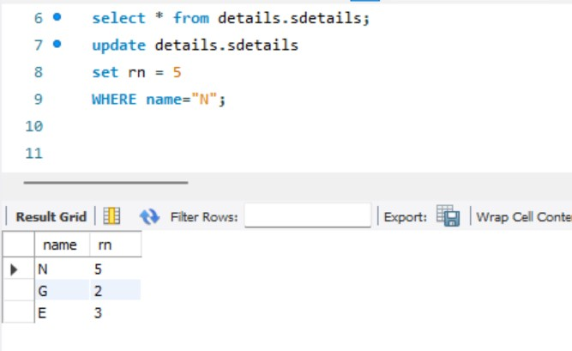

**JOIN OPERATIONS:**

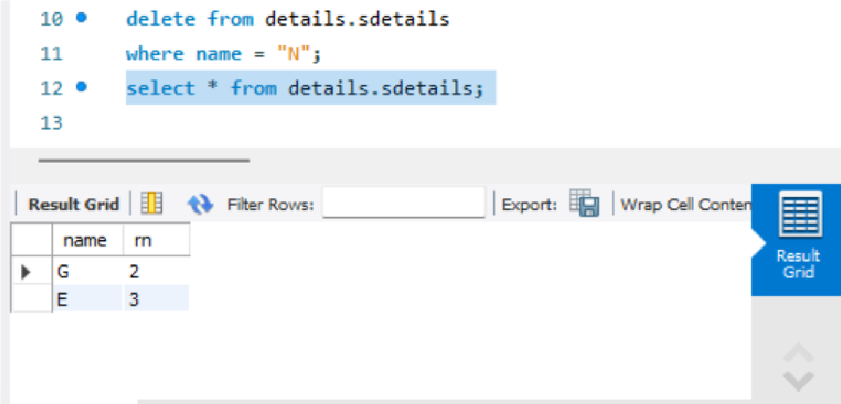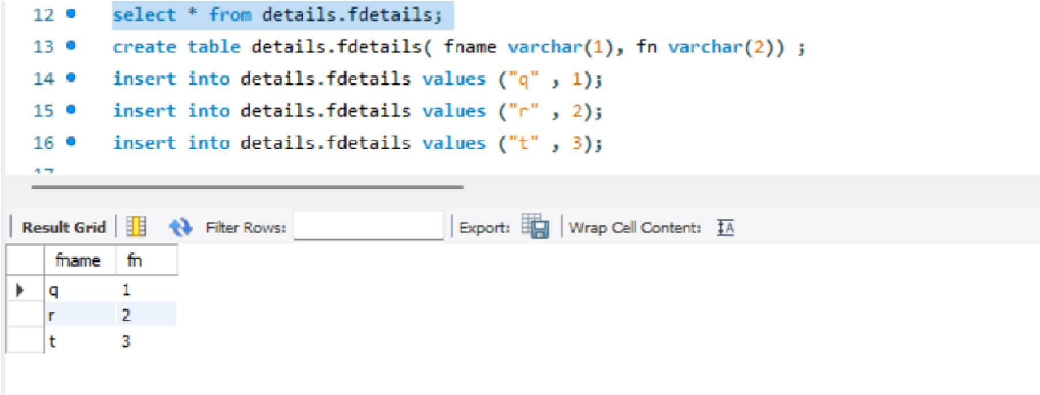

Code:

Inner join:

select fdetails.fn, fdetails.fname, sdetails.name, sdetails.rn from details.sdetails inner join details.fdetails on fdetails.fn = sdetails.rn;

Left outer join: select fdetails.fn, fdetails.fname, sdetails.name, sdetails.rn from details.sdetails

left join details.fdetails on fdetails.fn = sdetails.rn;

Right outer join: select fdetails.fn, fdetails.fname, sdetails.name, sdetails.rn from details.sdetails RIGHT join details.fdetails

on fdetails.fn = sdetails.rn;

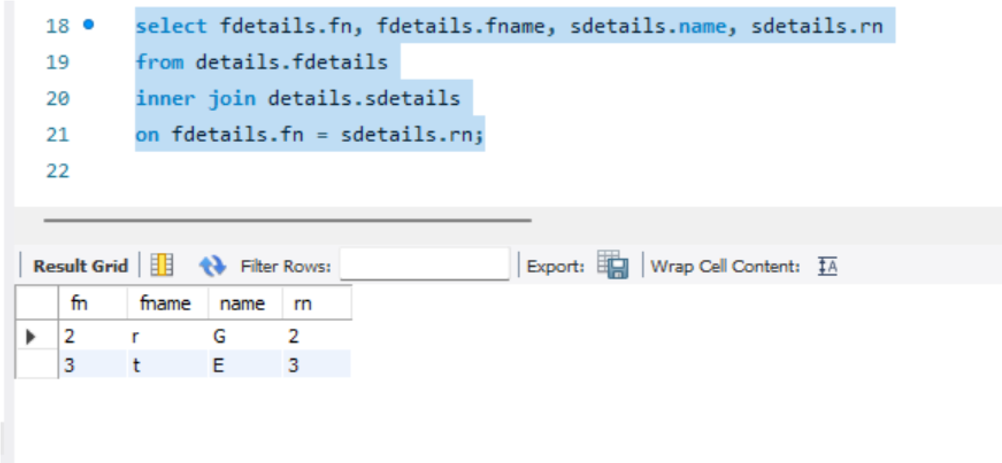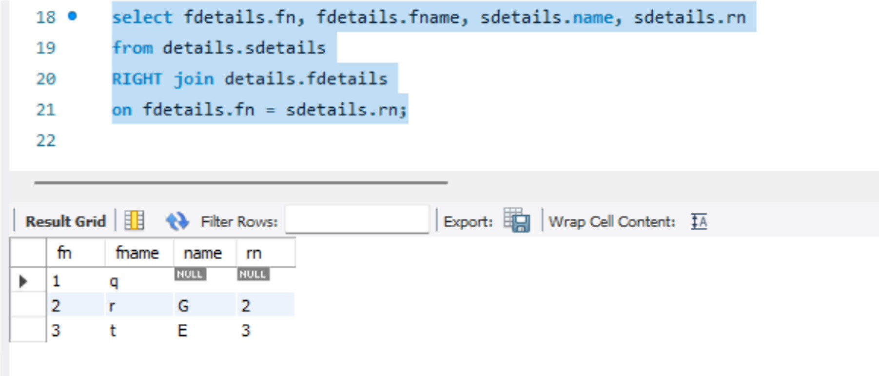

**Mangodb code:**

